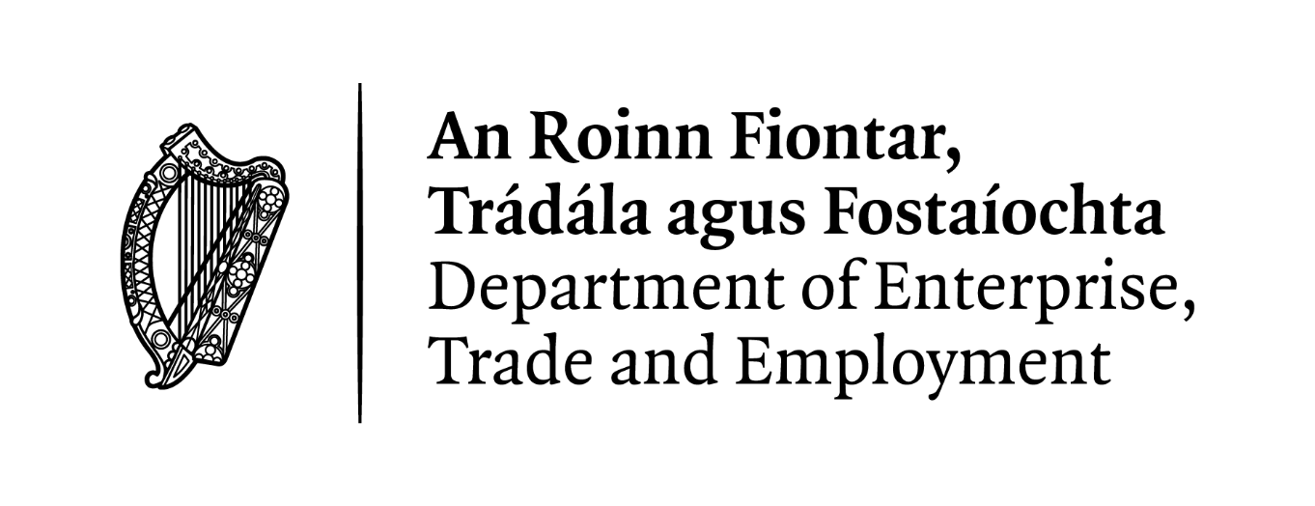

Data Protection
Subject Access Request (SAR)
Application Form

Request for access to Personal Data under the General Data Protection Regulation (GDPR) and Data Protection Acts 1988-2018.

Notes:
- In order to respond to your request for personal data, you will need to provide us with adequate Proof of Identity.
- Where a request is manifestly unfounded, excessive, of a repetitive nature or where more than one copy of the data is sought, a fee may apply.
- You may contact our Data Protection Officer to assist you in the completion of this Form.
- A copy of our Privacy Statement is available at: enterprise.gov.ie/en/Privacy-Statement

Data Retention
We will only keep a copy of these documents until your subject access request has been fully processed and issued to you and all relevant review or appeal procedure timelines have expired.

Please complete all parts of this Form in full.

Part 1 – Details of Data Subject (Your Details)

Contact Details (in block capitals):

Name: ___________________________________________________________________________________________

Surname: ________________________________________________________________________________________

Address: __________________________________________________________________________________________

_____________________________________________________________________________________________________

_____________________________________________________________________________________________________

Eircode: ___________________________________________________________________________________________

Contact Phone Number: _________________________________________________________________________

E-mail Address (where applicable): ____________________________________________________________

Part 2 – Details of Request

Help Us to Help You!

To assist us in locating the data you are requesting, please include as many specific details as possible in relation to your interactions with us in the past (e.g. please state the area(s) of the Department/Office you have corresponded with/the types of applications you may have made, etc).

_____________________________________________________________________________________________________

Please tell us the relevant period of time or timelines involved (i.e. the relevant dates e.g. 01 January 2022 – 31 December 2022 for which you are seeking the personal data).

____________________________________________________________________________________________________
Please provide us with any reference numbers relating to your contact with us in the past (e.g. previous correspondence references, case reference numbers, etc.).

____________________________________________________________________________________________________

_____________________________________________________________________________________________________

_____________________________________________________________________________________________________

_____________________________________________________________________________________________________

_____________________________________________________________________________________________________

_____________________________________________________________________________________________________

Please provide us with any other specific details that you feel are relevant in assisting us in locating your personal data. (e.g. by providing us with as much detail as possible in relation to your access request, we will be able to assist you more efficiently).

____________________________________________________________________________________________________

_____________________________________________________________________________________________________

_____________________________________________________________________________________________________

_____________________________________________________________________________________________________

_____________________________________________________________________________________________________

_____________________________________________________________________________________________________

_____________________________________________________________________________________________________

_____________________________________________________________________________________________________

_____________________________________________________________________________________________________

_____________________________________________________________________________________________________

_____________________________________________________________________________________________________

Part 3 - Declaration

I declare that all the details I have provided in this Form are true and complete to the best of my knowledge.

Signature of Requester: _____________________________________________

Date: _________________________________

Please return the completed Form by post to:

Data Protection Officer
Department of Enterprise, Trade and Employment
23 Kildare Street
Dublin 2
D02 TD30

Or by e-mail to:
dataprotection@enterprise.gov.ie

Further information on Data Protection:

Data Protection Commission
Irish Supervisory Authority for Data Protection issues
See: www.dataprotection.ie

Contact Information is also available at:
www.dataprotection.ie/en/contact

Part 4 - Checklist

Please remember to check that you have:

- Completed the Subject Access (SAR) Request form in full - YES/NO
- Signed and dated the Declaration on page 4 - YES/NO
- Provided us with sufficient details to locate your personal data - YES/NO
- Provided adequate Proof of Identity - YES/NO

