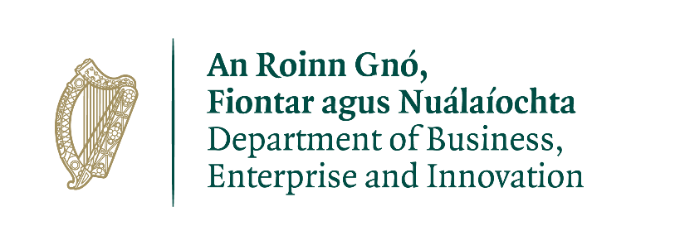

Council Directive 2005/71/EC* regarding admission of third-country nationals for the purposes of scientific research

Renewal of Accreditation of Research Organisations

Contents

Application form for Renewal of Accreditation of a Research
Organisation for the purposes of Council Directive 2005/71/EC.

Research Organisations wishing to renew their Accreditation as a Research Organisation for the purposes of Council Directive 2005/71/EC should ensure that they re-familiarise themselves with the criteria and terms and conditions of the scheme and confirm by letter that they continue to comply with the criteria and terms and conditions of the scheme.

A Research Organisation wishing to renew its accreditation under the terms of the scheme should re-apply to the Innovation, Research and Development Policy unit of the Department of Business, Enterprise and Innovation one month before the expiration of its Accreditation. Part 1 (below) - Application form for Renewal of Accreditation – should be completed and accompanied by a letter confirming that the research organisation continues to comply with the criteria and terms and conditions of the scheme. (Part 2).

Part 1

Application form for the Renewal of Accreditation of a Research Organisation for the purposes of Council Directive 2005/71/EC.

Name of Research Organisation:
Address:
Contact Person: Position:
Phone: Email:
Signature:
Title:
Date:

Note: Signatory for research organisation must be the Secretary to the governing body of the organisation or person duly authorised by the governing body to sign this application form.

N.B. Where there have been any significant structural or policy changes to the Research Organisation since the original period of Accreditation, please give details.

Return to:
Gary Phipps,
Innovation, Research and Development Policy Unit,
Department of Business, Enterprise and Innovation,
23 Kildare Street,
Dublin 2.

Part 2

Template for Letter of Renewal of Accreditation

I hereby wish to apply for renewal of Accreditation on behalf of -------- (Name of Research Organisation) as a Research Organisation for the purposes of Council Directive 2005/71/EC.

I confirm that ----- (Name of Research Organisation) continues to comply with the criteria and terms and conditions of the Scheme.

Signed:

Date:

Name of Research Organisation:

Note: Where there have been any significant structural or policy changes to the Research Organisation since the original period of Accreditation, please give details.

* OJ L 289, 3.11.2005

